# MN Wild Deaf/HOH Hockey

Minutes of the Monthly Meeting of the Board of Directors

October 10, 2024

8:00pm to 9:00pm

Meeting Location: Virtual

**Board Members:** Rai Fusco, Abi Girard, Amy Caslow, Jack Rugroden, Sandi Cariveau

**Guests:** None

**Absent**: Carolyn Lane, Toni Gillen, David Uzzell, Gina Alvarado

Call To Order

The regular meeting of the Board of Directors of the MN Wild Deaf/HOH Hearing Hockey Program was called to order at 8:00 pm on October 10, 2024, by Rai Fusco:

## Approval of Agenda

* The agenda for the meeting was distributed by Rai
* Discussion: None
* Motion to Approve by: Rai
* Seconded by: Sandi
* Vote: Unanimously approved

## Secretary’s Reports / Review of Previous Minutes

* Discussion: To be emailed for approval
* Motion to Approve by:
* Seconded by:
* Vote:

## Officer’s Reports

* President’s Report – Rai
  1. Roles Update: Amy
     1. Head Coach and Coaching Coordinator: Tony Reineccuius has accepted
        1. Patrick Anderson, Anderson Goaltending, Assistant Coach
        2. Alex Z has Level 1 coaching and will also assist
     2. Interpreter Coordinator: Gina Alvarado (not present)
        1. There has been some difficulty in securing interpreters.
     3. Team Manager: TBD
        1. Position is to manage Sports Engine, handle communication between coach and players, set up equipment
        2. Alex can set up lights but unable to take on Team Manager role
        3. We are hoping a parent or player will take this role. To be discussed at first session 13-October.
     4. Webmaster: Lindsay Lein has resigned and trained Justin Small, Abi Girard, Sandi Cariveau
  2. MN Wild Adult Hockey League
     1. Information in slide below – not limited to Deaf players
     2. Do we have enough adults for this? Would we need to schedule ice? Concern is this program would detract from our mission and current program if we divide the groups. Possibly have an adult game/scrimmage every ~3rd scrimmage at the end of the session?
     3. Rai to discuss with Toni

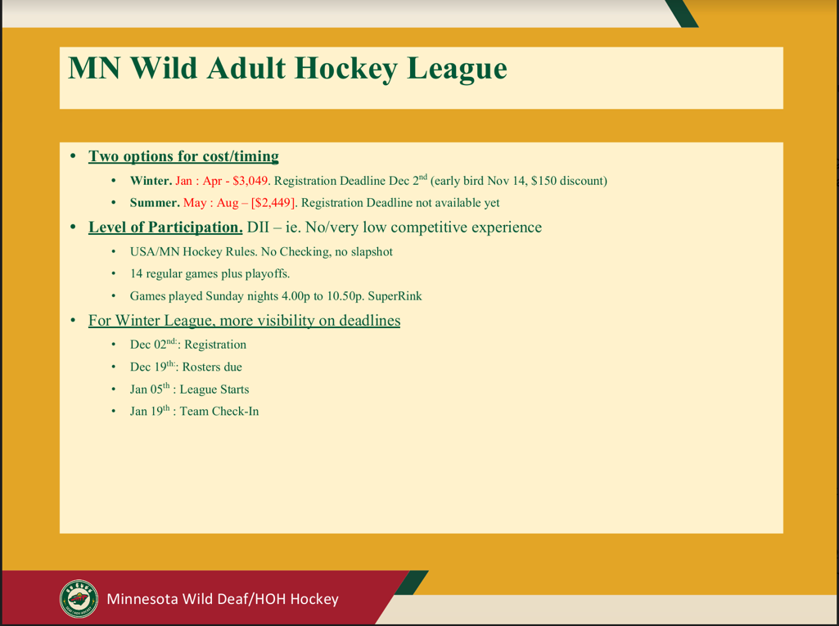

* Treasurer’s Report – Edina Community Foundation
  1. Balance as of September 30, 2024: $79,831

## Standing Committee Reports

## Fundraising Report – Rai : N/A

## Team Manager Report – TBD : N/A

## Equipment & Ice Report – Jack

* + - Winter/Spring: Schedule 2 sessions per month for total of 10 sessions beginning in January. SLP would be first choice, followed by Blaine Super Rink
      * Amy motion to approve, Rai second, Unanimously approved

## Marketing Report – Abi

* + - Working with Tim on swag for December 15 party.

## Volunteer Report – Amy

* + - Discussed above in President’s Report

## Special Committee Reports

* + MN Diversified Hockey Report – Toni
    - No report this meeting

## Old Business

*Did not discuss this meeting due to time*

1. AHIHA Sponsorship
2. Accessibility – Teaching coaches signs to use during practice.
3. Player Retention and Feedback
4. Hockey Day MN 2025 Shakopee - Do we still have a chance to be part of this day?

## New Business

1. Lighting system – Rai requested up to $250 for light stands and adapters.
   * + Rai motioned, Sandi second, Unanimously approved
2. Battery System – Rai will email board with details and request
3. Storage – Currently equipment is in Rai’s home. Rai to coordinate with Coach Tony
4. Coach Stipend – Rai to review with Toni

## Announcements

The next regular meeting will be held in 6 weeks: Wednesday, November 20th 8pm CT

## Meeting Adjournment

The meeting was adjourned at 9:04 pm by Rai

Minutes submitted by:

Sandi Cariveau